**Lab 3 - Packet Tracer**

|  |
| --- |
| * This is an assignment, and worth 5 points. * The due date is today’s midnight. * Submit this outcome file. * ~~Submit two *.pkt files.~~ |

**Task 1.**

Complete all the Parts in the following file: *2.1.1.2 Packet Tracer - Deploying and Cabling Devices.pdf*.

Build on the attached file: *2.1.1.2-Deploying and Cabling Devices.pkt*.

- Take a screenshot of the outcome (refer to p. 4).

**Task 2**.

Complete all the Parts in the following file: *2.1.1.4 Packet Tracer - Configure End Devices.pdf*.

- Take a screenshot of the outcome of ping (refer to p. 3).

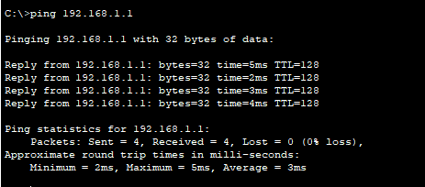

- Take a screenshot of the outcome of running IOS commands (refer to p. 7).

