Group member names: Aaron Henry, Michael Ly, Dhara Patel, Max Phillips, Ryan Bell

**Exercise 11: Problem Solving** (10 points)

**Instructions:**

1. This is a group assignment. You only need to submit one solved exercise per group.
2. You would only submit your SQL statements one single PDF file. If there are any notes you would like me to look at, please include those with the SQL statement.
3. Every group member needs to run the SQL statements in their account. I have access to your database and will examine the individual work done.
4. Once finished, upload the file to the appropriate assignment response in blackboard.
5. You may upload as many attempts as you may like. Please note that only the most recent file uploaded file would be graded.
6. Do not handwrite any responses.
7. If you have any additional information you would like me to know about this assignment, you may provide that to me at the end of this document as a note.

**Use the data model shown at the bottom of this document for this assignment:**

What to do:

1. This assignment must be completed in SQL Server. No other DBMS is allowed.
2. All SQL statements written by different team members should be collated in this one single document in its appropriate area. No exceptions.
3. **Write a query for each of the following questions. The tables are in a database called PET. You can access the tables by qualifying the tables as in the following example: SELECT * FROM PET..CUSTOMER**
4. Copy paste these SQL statements in appropriate space in one single document.
5. ERD for the database is provided at the end of this document.
6. You would not create/copy this database into your account. It is included in your schema and you would access it following instructions in #3 above.

**Assignment:**

1. Which merchandise items with a list price of more than $50 had no sales July?

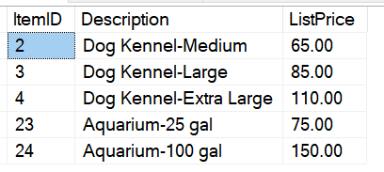

SELECT M.ItemID, M.Description, M.ListPrice

FROM PET..Merchandise M

WHERE M.ListPrice > 50 AND M.ItemID NOT IN (SELECT SI.ItemID

FROM PET..Sale S

INNER JOIN (SELECT SI.ItemID, SI.SaleID

FROM PET..SaleItem SI

) SI ON S.SaleID = SI.SaleID

WHERE MONTH(S.SaleDate) = 7)

1. Which merchandise items with more than 100 units on hand have not been ordered in 2004? Use an outer join to answer the question.

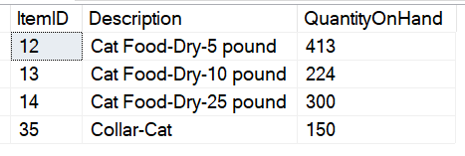

SELECT M.ItemID, M.Description, M.QuantityOnHand

FROM PET..OrderItem OI

FULL OUTER JOIN PET..Merchandise M ON OI.ItemID = M.ItemID

FULL OUTER JOIN PET..MerchandiseOrder MO ON OI.PONumber = MO.PONumber

WHERE M.QuantityOnHand > 100 AND MO.OrderDate IS NULL

1. Which merchandise items with more than 100 units on hand have not been ordered in 2004? Use a subquery to answer the question.



SELECT M.ItemID, M.Description, M.QuantityOnHand

FROM PET..Merchandise M

WHERE M.QuantityOnHand > 100 AND M.ItemID NOT IN (SELECT OI.ItemID

FROM PET..OrderItem OI)

1. List all suppliers (animals and merchandise) who sold us items in June. Identify whether they sold use animals or merchandise. One way to do this is to use a union query. You can tag the sale type by just using 'Sold Us Merchandise in June' AS 'Type of Sale' or 'Sold Us Animals in June' AS 'Type of Sale' in the query.

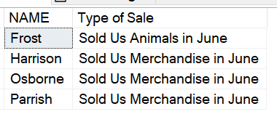

SELECT S.Name,'Sold Us Animals in June' AS 'Type of Sale'

FROM PET..Supplier S

INNER JOIN PET..AnimalOrder AO ON S.SupplierID = AO.SupplierID WHERE MONTH(AO.OrderDate) = 6

UNION ALL SELECT S.Name, 'Sold Us Merchandise in June' AS 'Type of Sale'

FROM PET..Supplier S

INNER JOIN PET..MerchandiseOrder MO ON S.SupplierID = MO.SupplierID WHERE MONTH(MO.OrderDate) = 6

ORDER BY S.Name

