**Inception Specifications**

**Team 5 – Team Sailor Moon**

**Cameron Abell, Denis Dzankovic, Mahendra Khanal, Christopher Lund, Michael Ly, Alexander Schoborg, Regis Wilson**

**System Request – Wilderness Louisville**

|  |  |
| --- | --- |
| **Project Sponsor:** | Bennett Knox, Parks Administrator |
|  |  |
| **Business Need:** | Improve user access to information  Create centralized database for customer relation usage |
|  |  |
| **Business Requirements:** | Provide online access to information, news and events  Include donation and membership purchasing capabilities  Include contact and newsletter forms  Integration with social media  Include booking and rental capabilities |
|  |  |
| **Business Value:** | Expected value that the system will provide; the benefits that the organization should expect from the system |
|  |  |
| **Special Issues or Constraints:** | Any additional information that may be relevant to the stakeholders; a catch-all for other information that should be considered in assessing the project (for example, specific deadlines that need to be met) |

Vision (Small Project)

# Introduction

The purpose of this document is to collect, analyze, and define high-level needs and features of the Wilderness Louisville website. It focuses on the capabilities needed by the stakeholders and the target users, and why these needs exist. The details of how the Wilderness Louisville website fulfills these needs are detailed in the use-case and supplementary specifications.

## References

Bernheim Arboretum and Research Forest. (n.d.). Retrieved September 21, 2020, from <https://bernheim.org/>

Broad Run Park. (n.d.). Retrieved September 21, 2020, from <https://www.theparklands.org/Parks/Broad-Run-Park>

Net Present Value Calculations: 2018 Online Giving Statistics, Trends &amp; Data: The Ultimate List of Giving Stats. (n.d.). Retrieved September 21, 2020, from https://nonprofitssource.com/online-giving-statistics/

# Positioning

## Problem Statement

The problem of Wilderness Louisville is that there is a lack of a central data repository. This affects potential donors and customers to Jefferson Memorial Forest, and impacts the profit generated by these donations. With less donations being made to the park; Wilderness Louisville isn’t receiving the funds needed to improve the park and maintain its beauty. A successful solution to this problem would not only be safer for the consumer, it would generate the cashflow needed by the organization.

## Product Position Statement

Wilderness Louisville isn’t just for the people that already attend Jefferson Memorial Forest to walk the trails and absorb the beauty of the parks. In order to maintain a sustainable organization, there must be new consumers to be brought in that have never seen the park before. People who attend Jefferson Memorial Forest experience nature and escape from busy city life during their visit.

No two paths are the same, and this is true for every forest that one attends. We want people to come to Jefferson Memorial Forest for its beauty and revisit multiple times over. This is an experience that one can have alone or share with their family.

# Stakeholder and User Descriptions

The stakeholders will be anyone that participate in the betterment of Jefferson Memorial Forest, or the general community that come to enjoy the forest and the many trails it has to offer. Investors want to be sure that their money is getting put to good use, while at the same time employees need to have jobs that make their work meaningful and not wasteful of current funds. The community want to have a beautiful and carefree experience that they can enjoy with their families, without the hassles of admission to the forest or other potential restrictions.

## Stakeholder Summary

|  |  |  |
| --- | --- | --- |
| **Name** | **Description** | **Responsibilities** |
| **Investors** | The people that donate, or have the ability to donate to the organization. | Funds the park to ensure that the projects that Wilderness Louisville want to initiate have the money to do so. |
| **Employees** | The people who work for Wilderness Louisville or Jefferson Memorial Forest | Ensures that the park is maintained for customers to enjoy. |

## User Summary

|  |  |  |  |
| --- | --- | --- | --- |
| **Name** | **Description** | **Responsibilities** | **Stakeholder** |
| **Customers** | The people that attend the park frequently. | Ensures that people will use the park. | N/A |
| **Event Coordinator** | The people that plan events and fundraisers for the park. | Attracts investors in order to raise more funds for Jefferson Memorial Forest. | Investor |

## User Environment

To complete the task of creating a successful website for Wilderness Louisville, our class of nearly 40 students, as well as the other section of CIS 320 students, are working in groups of six to identify areas of improvement and design a working layout. The first phase is planning, which will last about two months and consist of the necessary steps to plot the improvements needed to the Wilderness Louisville website.

Next will be the analysis phase, lasting about two weeks, and here we identify and analyze the problems further and how to improve the overall functionality of the website. It is important that the website be user friendly and readable to multiple devices, including phones, computers, and tablets. During this analysis step, we will analyze what features we want to include across these platforms.

The last phase is the design phase. This is where we will draw out what we envision the website to look like and plan for the actual coding of the website. This process will be started during the end of this year and won’t have working prototypes until next year.

## Summary of Key Stakeholder or User Needs

|  |  |  |  |  |
| --- | --- | --- | --- | --- |
| **Need** | **Priority** | **Concerns** | **Current Solution** | **Proposed Solution** |
| **Lack of central data repository** | High | Difficult to contact donors and customers. High risk of data being compromised. Hard to write grants. | Continue using the current system | Switch to a more advanced systems that can monitor and record user data, as well as website traffic. |
| **Drive revenue through donations and storefront** | Medium | Cannot gain funds needed to support projects and development. | Wait for potential donors. | Advertise, create a media presence, or start a merchandise store to promote the forest. |
| **Lack of an online presence** | Medium | No blog or social media platforms to keep users informed. | Newsletters through email. | Create social media postings and spread the word. |
| **Lack of mobile presence** | Low | Many users on the go access the website on their phones, to which the user interface fails. | Design simple website that doesn’t need many tweaks when moved to mobile. | Design with mobile in mind and not sacrifice quality for lazy programming. |

## Alternatives and Competition

Other big public parks and forests are The Parklands of Floyds Fork and Bernheim Forest. The strengths they have are that both of their websites are very well developed and contain a lot of the key features that Wilderness Louisville is lacking. The users of these website don’t have to try hard to obtain the information that they seek, and it is very easy for any potential donor to provide funds to the park.

One key weakness with The Parklands, however, is that their website is catered to the casual walker and outdoor individual, rather than a hike and memorial forest. A weakness of Bernheim Forest is that it isn’t as local as some of the other options for people living in the Louisville area. Jefferson Memorial Forest would be competitively closer and provide ease of access to any local party.

# Product Overview

A well-produced website has the capabilities to drive revenue by increasing website traffic and maintaining audience interest. The goal in improving the website is to provide the user with a better experience and ultimately look more polished for potential visitors and donators.

## Product Perspective

The website will be a stand-alone object that provides the users with immediate access to any information they need. This information can include, but is not limited to:

* + Information about upcoming events and activities at the forest.
  + Information about trails, parks, lakes, and rivers.
  + Information about plants and wildlife that can be found at the park.
  + Important news about the park, including closures, warnings, and other special notices.

Although the website itself is stand-alone, other aspects of the website such as the events calendar and social media links will be different ways that the users can get the information. Social media in particular is a great way to keep people informed because it is a place that the general population frequently checks. Two big social media platforms would be Facebook for more general updates, as well as Instagram, where the pictures of park scenery will attract new visitors.

## Assumptions and Dependencies

If Wilderness Louisville makes the decision to opt out of having a social media presence and stick to a more conventional form of email and newsletter communication, this would alter the need for an event calendar and blog postings. This may save resources that were allocated to the promotion of the park and would instead need to allocate in other projects and plans.

It is also important to note that because Jefferson Memorial Forest isn’t located in a central area of the city, attracting new people to the park can be problematic. If a social media presence is not the route that Wilderness Louisville would like to take, a top priority would have to be some other form of advertising for the park. Website traffic would need to be monitored tracked after different events to ensure that the forest is getting the exposure it needs to generate the maximum amount of money possible.

# Product Features

Website features can promote the user's interest in the website while. This can affect the amount of money generated from donations because the website looks more polished and tidier. Some of the features that we would like to include in the Wilderness Louisville website are an event calendar, slideshow of photos at the forest, forest map, community recommendations, and planned projects.

These features each have their own benefits to the site, but all share an overall goal of improving usability and bringing in website traffic. An event calendar would display upcoming events in an orderly way and give the user an opportunity to get involved. Such events could be fundraisers, picnics, and hiking club gatherings. These social events encourage more families to get involved with Wilderness Louisville, which could net more donations. The level of effort in creating this feature would be minimal and would only need to be updated once when a new event is planned. Depending on the frequency of planned events, this should only take five minutes to add an event.

The slideshow of photos taken at the park would highlight the beautiful scenery that the park has to offer. From gentle rivers to dense forest, any visitor is sure to experience many aspects of nature that they can share with their friends and family. The slideshow would change with the difference seasons, showcasing the forest’s beauty during all parts of the year. The level of effort to showcase these pictures would be minimal. Once the pictures are imported into the slideshow, they will only need to be updated once a season.

A forest map would provide the user with direct navigation to the different points of interest at Jefferson Memorial Forest. Trail markers, lakes, help desks, restrooms, and gift shops are just some of the places that any user would love to discover. Google maps already provides a good baseline for a map of the park. To add the points of interest, simply document the location of each of the main trail heads.

Community recommendations could be a great way to have people more interactive on the website. The user can simply type their email and a comment, and it would instantly be posted to the website for other users to see. These recommendations could be for any newcomer to find out what they must see during their visit at the park. By increasing community involvement, we increase the likelihood that the consumer will come back to the forest or potentially donate. This would generally require much more time than the other features of the website. Someone would be required to monitor and moderate the comments and recommendations in case of malicious activity. Though generally not a big deal with low traffic websites, this is still noteworthy.

Finally, a planned projects feature will provide the community with information about the upcoming improvements and developments for the future of Jefferson Memorial Forest. Giving this insight to the public will further increase community involvement, especially if the improvement project is something that the general public will benefit from, such as a new picnic area, a new paved path, or a recreation area. The users will then be able to donate directly to that project if they choose in order to speed up the project’s progress. If a project shows very little interest or traffic, it will also save time and money by Wilderness Louisville because they can allocate their resources to other, more attention-grabbing projects. Similar to the event calendar listed above, this would require very minimal effort as projects are typically infrequent and would only need to be posted once. A project posting should take no longer than 30 minutes to provide a thorough description of the project intended.

# Other Product Requirements

Since Wilderness Louisville does not require any account creation or storage of user personal data, the size of the website will be very small. Hardware to hold such a website will not be hard to obtain, but it is important that the website itself is secure and has good performance for the user. Links on the website should be quick to load, and the design should be clean and easy to look at.

The website will be sustainable by the donations of the users. Website traffic could take a toll on the performance of the website, so it will also be important to monitor the traffic.

# Calculated Net Present Value

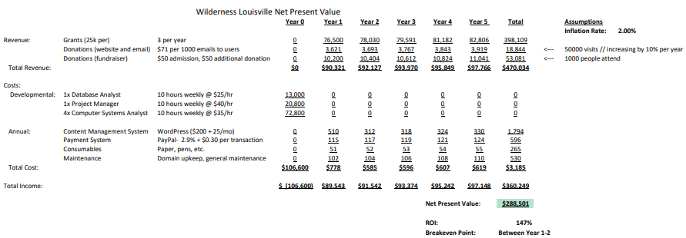

The expected revenues calculated came from grants and donations totaled to be $470,000 in a total of 5 years. This number was generated off of the assumption that the Wilderness Louisville website currently has 50,000 visitors yearly, and with the improved website, would receive a 10% increase to views each subsequent year. We also assume that fundraising events for the forest would have about 1000 attendees. Each attendee would pay a $50 admission and donate an average of $50 toward the fundraising goal.

The cost section was calculated in two parts: the amount that would be required to develop an improved website, and annual expenses required to upkeep the website. First, we predicted in that a team of 6 skilled developers and project managers would cost an initial investment of $106,000 for Year 0. After the upfront costs are incurred, it would take another year and a half for the website to breakeven. Other miscellaneous costs, such as website domain registration and office consumable costs are minimal. Over a five-year period, it would cost $360,000 to make and upkeep the website.

In total, the net present value of the website would total to be about $290,000. This profit could be used to fund various projects and development of forest services and maintenance.

# Appendix

## Feasibility Analysis

1. Technical Feasibility:

* Familiarity with Application: Wilderness Louisville staff and users will be able to use the website normally but with better navigation and design.
* Familiarity with Technology: Wilderness Louisville staff will be familiar to the website we’re planning to integrate, but those who are expected to help edit the webpage for the website should have less difficulty than their old static website.
* Project Size: It’s expected to be a relatively small project with the risk being low. It’s expected that the project will be completed within a few months where it might be expected to be integrated with the donation payment system “Bloomerang”.
* Compatibility: Low risk because the features are being created from scratch or can be used with other programs.

1. Economic feasibility:

* Development cost:
* Development Team Salaries: $0 (if developed by team) and $500 - $1000 by 3rd-party web developer
* Consultant Fees: $0
* Annual Operating Costs: Payment System Fee: $0
* Annual Benefits:
* Money gained from better developed website: $15,000 - $45,000
* Money gained from Writing Grants: $50,000 - $75,000
* Intangible Costs and Benefits:
* Increased community engagement and volunteers

1. Operational Feasibility:

* Project Champion: Andy Reynolds (chair) and Vicki Welch (vice chair)
* Senior Management: Andy Reynolds, Vicki Welch, Charlotte Caldwell (treasurer) and Patricia Tennen (secretary)
* Users: Donators, Volunteers, Wilderness Louisville Staff
* Other Stakeholders: Donators and Volunteers

The project will help support the cause of the organization by re-developing the websites for PC and mobile users as well as creating social media account on various platforms. This will help Wilderness Louisville operate more efficiently and increase the organization’s popularity.

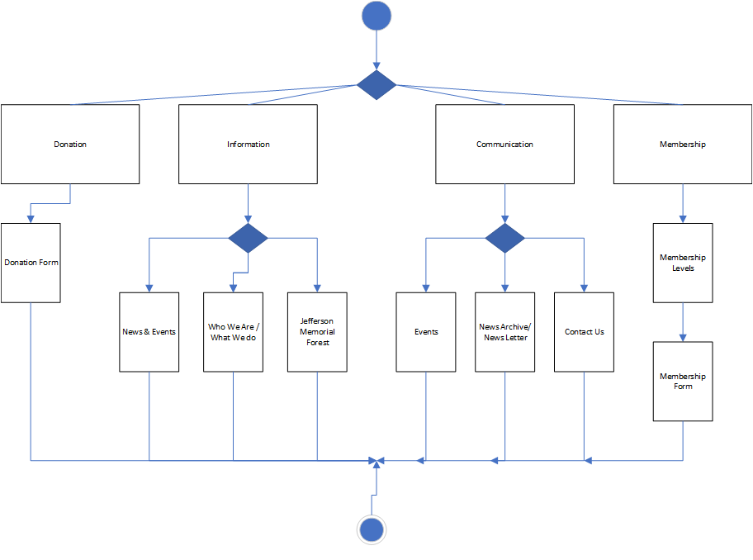Process Models

AS-IS

With the very limited functionality that the current Wilderness Louisville Website has, it is really only possible to look at the home screen and the donation screen. This is not very appealing to the overall goal of the organization, which is to raise money.

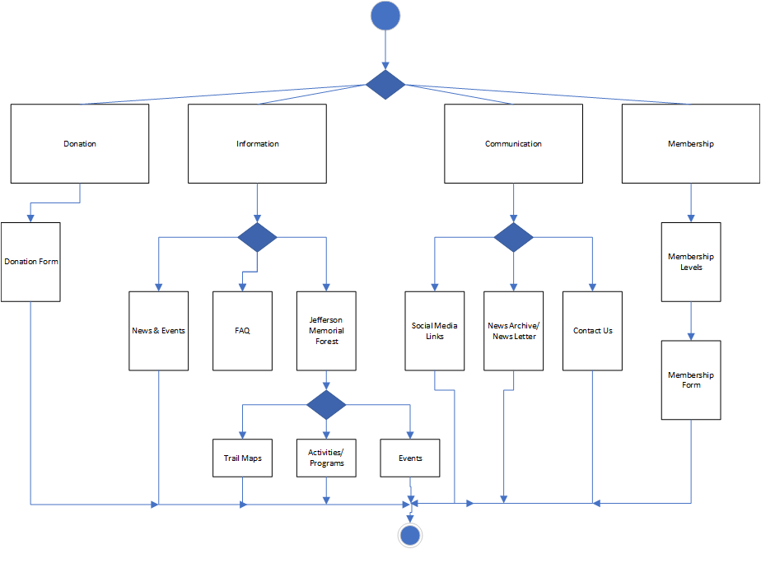TO-BE

The TO-BE model emphasizes the quality of website we would like to create. With 8 different navigation tabs, it is possible for the user to quickly find what they are looking for and can look at the different options available that are both tidy and easy to look at.

**System Requirements**

This section lists the features that our system must be able to implement in order to create ease and efficiency for Wilderness Louisville.

1. The system will have an easy system for contacting donors and customers.

2. The system will have a significantly lower risk of data compromised.

3. The system will have a connection to the park system.

4. The system will be able to track website visitors and traffic.

5. The system will have a notable online presence for swag.

6. The system will have a strong mobile presence.

7. The system will have easy navigation control on mobile version.

8. The system will have the ability to drive traffic to the park.

9. The system will have a board member accessing portal for park information.

10. The system will have the website tied to social media accounts.

11. The system will have the ability to manage social media accounts from one central location.

12. The system will have the ability to drive revenue through grants.

13. The system will have the ability to drive revenue through donations.

14. The system will have the ability to drive revenue through storefront.

15. The system will have a easy and clear section to sign up volunteers.

16. The system will have the ability to manage volunteers easily.

17. The system will have a clear, quick, and secure way to donate.

18. The system will have information programming for grant writings.

19. The system will have an interactive map of the park.

20. The system will have a discussion board.

21. The system will have a voting forum

**Use Cases**

The use cases are constructed as overview. The essential use cases include the use case name, the primary actor, and a brief description describing what their purpose is.

**-Use Case 1**

(1) Adding Members and Donors to the System.

(2) The primary actor in this case is a new member or donor to the site

(3) The user can enter their name and contact info on an easy to use form, after which it will be stored in a well-organized database within the system for later reference.

**-Use Case 2**

(1) Editing Member and Donor Info

(2) The Primary actor in this case is a user seeking to edit existing contact info that is out of date.

(3) The user will be able to access their contact info from the site’s data repository of members and donors and be able edit their contact information should it become out of date.

**-Use Case 3**

(1) Deleting Members or Donors from the System

(2) The Primary actor in this case is a user seeking to remove their contact info from the site’s data repository for some reason.

(3) The user will be able to access the data repository and have a clear option to delete their info from the site to prevent further contact.

**-Use Case 4**

(1) Securing Site Info

(2) The primary actor in this case is the site designer who decides in what way data for the site will be stored and secured.

(3) The user in this case stores the data in a way that cannot be infiltrated by hackers seeking to steal the personal information of members and donors.

**-Use Case 5**

(1) Accessing the Parks System

(2) The primary actor in this case is a user looking into the other parks associated with Wilderness Louisville.

(3) The user will be able to click a well-marked link from a full list of parks associated with Wilderness Louisville that will take them to it’s respective website.

**-Use Case 6**

(1) Monitoring User Traffic

(2) The Primary actor in this scenario is a site admin seeking info on traffic to the site.

(3) In this case the user will be able to view metrics on how many people viewed the site, how many clicks were made within the site, and many other measurements that can be used to measure the effectiveness of site changes and other strategic moves.

**-Use Case 7**

(1) Finding the site online

(2) The primary actor in this case is a first-time site user looking to access the site after hearing about it.

(3) In this case the user attempts to find the site by either using the url, or more likely, through a search engine, which should be an easy process if the site has a notable online presence.

**-Use Case 8**

(1) Using the site on mobile

(2) The primary actor in this case is a user hoping to access the site on a mobile device.

(3) The user will be able to access the site on their mobile device and will have the same user friendly and workable experience as they would on a PC.

**-Use Case 9**

(1) Locating the Park

(2) The Primary actor in this case is a user who has seen the site and has decided to visit the park because of it.

(3) The user will be able to use an easy to find Visit the Park portal in order to find the address and location of the park.

**-Use Case 10**

(1) Accessing Board Member Info

(2) The primary actor in this case is a Board member who wishes to use the site to find information on the park.

(3) The user will be able to click the Board member access portal which will take them to a page containing information specific to them as a Board Member.

**-Use Case 11**

(1) Accessing the Twitter Page

(2) The Primary Actor in this case is a user who is interested in seeing Wilderness Louisville’s Twitter page.

(3) The user will be able to click a link that reads “Follow us on Twitter!” and will be taken straight to the company’s twitter page.

**-Use Case 12**

(1) Accessing the Facebook Page

(2) The Primary Actor in this case is a user who wants to view the company Facebook page.

(3) The user will be able to click an obvious link reading “Visit Out Facebook” which will take them straight to Wilderness Louisville’s Facebook page.

**-Use Case 13**

(1) Sharing Wilderness Louisville

(2) The Primary actor in this case is a site user looking to share an upcoming event or piece of news from Wilderness Louisville.

(3) The user in this case will be able to select a “Share!” button within a Newsletter or announcement where it will give them a selection of Twitter or Facebook, where they will have a premade post with a link to the Newsletter or announcement in question.

**-Use Case 14**

(1) Posting to Company Social Media

(2) The primary actor in this case is a site admin looking to use the system in order to post to Wilderness Louisville’s Social Medias.

(3) The user in this case will be able to provide a message or picture to the system which will in turn be posted on all of the selected platforms simultaneously.

**-Use Case 15**

(1) Editing Social Media Info

(2) The primary actor in this case is a site admin seeking to edit info on the company’s social media through use of the system.

(3) The user in this case will be able to view the existing information on the selected pages, edit it, and have the changes sent throughout all the selected platforms.

**-Use Case 16**

(1) Deleting Social Media Posts

(2) The primary actor in this case is a site admin seeking to delete posts from a company social media platform through use of the system.

(3) The user in this case will be able to view recent posts made on the platforms selected and will have the option to delete the post, which will automatically remove it from the selected platforms.

**-Use Case 17**

(1) Receiving Grants

(2) The primary actor in this case is a user seeking to give Wilderness Louisville a grant.

(3) The user in this case will be able to access a grant informational page, where the user will learn about Wilderness Louisville, and how a grant will benefit the community and the park.

**-Use Case 18**

(1) Donating through the site

(2) The primary actor in this case is a user who wishes to donate to the park.

(3) The user in this case will be able to select the “Donate” page, where they will be able to select a donation amount and be able to proceed with trusted and secured software for such financial transactions.

**-Use Case 19**

(1) Viewing Site Storefront

(2) The primary actor in this case is a user wanting to see what Wilderness Louisville has in the way of apparel and other goods.

(3) The user in this case can select the “Store” page where they can view various items Wilderness Louisville is selling.

**-Use Case 20**

(1) Ordering from the Store

(2) The primary actor in this case is a user who has decided they wish to buy an item from the store on the site.

(3) The user in this case will be able to add items to their “cart” and when ready choose “Checkout”

**-Use Case 21**

(1) Giving shipping and billing information

(2) The Primary actor in this case is a user who has begun their checkout in the site storefront.

(3) The user in this case will enter their shipping address, and their payment information using the same safe and secure software as the donations page.

**-Use Case 22**

(1) Add to the event calendar

(2) The primary actor in this case is a site administrator that is adding an upcoming event to the calendar.

(3) The user in this case will be able to select an “add event” option, where they will then be able to fill out a form including event name, time, date, and description.

**-Use Case 23**

(1) Modify the event calendar

(2) The Primary actor in this case is a site administrator looking to edit info on a park event in the calendar

(3) The user in this case will select an event on the calendar and select an “edit info button” which will take them to a form showing the current information listed on the event, where they can edit and resubmit the form.

**-Use Case 24**

(1) Delete the event on the calendar

(2) The Primary actor in this case is a site administrator that is looking to remove an event from the calendar that has either passed or has been postponed/canceled.

(3) The user in this case will select the event in question on the calendar and select a “delete” button that will automatically remove the event from the site calendar.

**-Use Case 25**

(1) Add to the suggestions

(2) The Primary actor in this case is a user that wishes to see something more added to the Wilderness Louisville website.

(3) The user in this case will select a button in the menu bar that says “Make a Suggestion” and can send a direct email or message to Wilderness Louisville officials.

**-Use Case 26**

(1) Vote on specific project ideas

(2) The Primary actor in this case is a user that wants to express their interest in a particular project or idea to be constructed soon.

(3) The user in this case will select the “Vote” page and will be presented with information on projects being considered for the park, and will be given an option to either vote in favor of, or against each proposed project or change.

**-Use Case 27**

(1) Add to a discussion board

(2) The Primary actor in this case is a user that wants to share their experience with other users.

(3) The user in this case will click on a discussion board or forum tab and be able to post about their experience in a text block.

**-Use Case 28**

(1) Modify or edit a post from the discussion board

(2) The Primary actor in this case is a user that wants to make changes to a post that they had originally made.

(3) The user in this case will click on a discussion board or forum tab and be able to modify their post about their experience in a text block.

**-Use Case 29**

(1) Delete a post from the discussion board

(2) The Primary actor in this case is the user who no longer feels like the post is relevant, or a site administrator that finds the post is not suitable.

(3) The user in this case will click on a discussion board or forum tab and be able to remove their post about their experience in a text block.

**-Use Case 30**

(1) Add a trail marker on the maps

(2) The Primary actor in this case is a site administrator that wants to add a new trail so that users can go visit.

(3) The user in this case will select the “Add a trail marker” button which will allow the user to select a location on the map, which will then prompt them with an informational form for them to fill out so people viewing the location on the map can see locational info.

**-Use Case 31**

(1) Delete a trail marker from the maps

(2) The Primary actor in this case is a site administrator that wants to change a trail marker that might be under construction or no longer in service.

(3) The user in this case will select the already made trail marker, and press “Delete Trail Marker.”

**Architecture Considerations**

Our architecture system is meant to help support Wilderness Louisville’s goals to help attract users and stakeholders to potentially increase donations as well as providing central data repository that can help manage and use data more efficiently for Wilderness Louisville Employees. The system has 5 main parts which is the firewall, web server, database server, cloud server and the mobile web server.

**Design Viewpoint:**

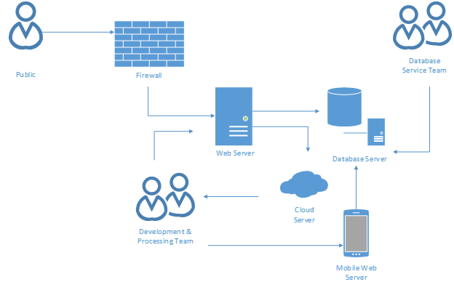

**Design:**

The web server will have support from its cloud servers to help backup any info that the development & processing team may use to help improve the website’s information and functionality for desktop and mobile users. The development & processing team will have both access to the web, database and mobile servers to help update and add any necessary changes for the website. The database servers help store and provides info for the web and mobile web servers in which the database service team helps backup the database servers to maintain its functionality and stability. The general public will have access to the website with the exception that it will be protected by a firewall for security measures in order to prevent tampering with the organization’s assets and data.

**Realization Viewpoint:**

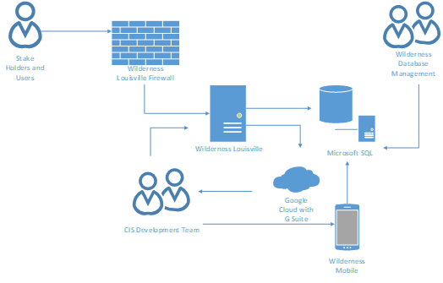

**Realization:**

Wilderness Louisville’s web data will be supported by Google cloud service with G Suite, which has a free price, to help store data that the CIS development team can use to help clarify information and fix necessary problems. The CIS development team will consist of UofL’s CIS team members and Wilderness Louisville’s Staff members. Wilderness Louisville’s web and mobile servers will highly be reliant on the database servers that will be using Microsoft SQL that manages and hold data for the other servers to use. Another option for the database servers is “MySQL” which is a guaranteed free and open-source software compared to Microsoft SQL where its cost is dependent on its price tier list limiting the software’s functions but has preset functions unlike MySQL. The Wilderness Database Management will keep watch on the functionality of the database servers as well as the information being accurate within the database server and making necessary changes if possible. The web server is “Wilderness Louisville” and the mobile web server is “Wilderness Mobile” where it will get its necessary updates for information and firmware changes from the database server with the help from the CIS development team that manages both the web and mobile server.  The website will be protected by the website’s firewall to protect sensitive data such as donations and discussion boards.

**Risk Analysis**

The criteria that assigns high or low risk value to each case shows how important they are to being done for Wilderness Louisville. We assign the risks to the user cases by evaluating the potential of what would help bring the most profit to Wilderness Louisville and cover the organization’s needs from each case.

|  |
| --- |
| Risk Cases |
| High Risk Cases Low Risk Cases |
| Accessing the Twitter Page Locating the Park |
| Vote on specific project ideas Using the site on Mobile |
| Securing Site Info Finding the Site Online |
| Accessing the Parks System Delete the event on the calendar |
| vote on specific project ideas Modify the event calendar |
| Receiving Grants Add to the suggestions |
| Sharing Wilderness Louisville Vote on specific project ideas |
| Accessing the Facebook Page Accessing Board Member Info |
| Posting to Company Social Media Ordering from the Store |
| Editing Social Media Info Giving Shipping and Billing Information |
| Deleting Social Media Posts Vote on specific project ideas |
| Deleting Members or Donors from the system Add to the discussion board |
| Adding members and donors to the system Modify or edit post from the discussion board |
| Delete a post from the discussion board |
| Add a trail marker on the maps |
| Delete a trail marker from the maps |
| Delete a trail marker from the maps |
| Add to the event calendar |
| Adding members and donors to the system |
| Monitoring user traffic |

Even though these use cases have their own risks, there are other factors that we need to take into consideration. The factors have their own level of risks based on the impact it could have on the organization. By looking at the following list, you’ll be able to see which risk can offer the greatest profit and contribution to Wilderness Louisville.

High Risk Low Risk

Web design/ interface Mobile Presence/ Development

Central Data Repository Donations

Media/ Online Presence

The risks can be used in the elaboration phase by considering any of the use cases and other factors that will contribute more to the organization, starting with higher risks. By analyzing and narrowing down the risks, it will help Wilderness Louisville understand what goals should be attainted in order to accomplish the organization’s intended mission. Also helps improve overall appearance and functionality of the website and social media accounts.

**Team Charter**

Our goals for Team 5 revolve around timely completion of each deliverable, while delegating work equally and explaining what how we’ve done what we’ve done along the way. While each team member may be working on something differently, we will each provide a short synopsis of what we’ve done and how it was completed, along with having each team member review the work as well. This allows for all presented material to be looked over by multiple sets of eyes to review any mistakes or contribute more material. This also includes every person in all facets of the deliverables, without having everyone do a little bit of everything. This allows people to focus on their own work while providing feedback and gaining insight into other areas along the way. In addition to our review process, we’ve set a goal of completing all deliverables 3 days in advance of the due date. This goal, while not always achievable, allows the team some buffer in the case of problems that will surely arise. Any miscommunication or issues that pop up in that time period will give us as a team ample time to respond.

Meetings for team 5 will be coordinated through Microsoft teams and through GroupMe. Ideally team meetings would occur in person, but due to the nature of COVID and online courses, our meetings will either be conducted through written method, or over Zoom in a virtual meeting instead. Our Team already meets regularly 3-5 times a week to discuss assignments over GroupMe. In addition to this, our Agile teams have separate group chats through text messaging to stay in contact as well. As a result, there is a constant stream of communication to help keep everyone connected and on track. Ideally, we will continue to be in communication 3-5 times a week to keep up to date and increase that as needed during project crunch times. Scheduled meetings are difficult to plan because some team members work night shifts while others work in the day, with little cross over in between, so it’s a challenge to have everyone all together. This makes Microsoft teams and GroupMe very important, as it allows us to catalogue our planning in a way that members who miss meetings can go back and review what was missed. Meetings will be led by rotating members and announced at least 1 day in advance in order to account for schedules. All decisions will be documented on a word file that will be put on Microsoft Teams for people to review.

While most communication for the team will be conducted through Group Me, and all material will be stored on Microsoft teams, communication will occur to the client and instructor will occur through one member through email, to allow for consistency. This designated Team member will be responsible for communicating any information, or asking questions to the instructor or client, that will all be kept through one email. This allows the client or instructor, if they should need to contact our team, to go to a single source that will have all documented communication in one spot. This eliminates any confusion, and keeps the team on track with information, as well as gives the client and instructor a point of contact that they know they can go to in order to reach our team.

When it comes to making decisions as a team, most choices will come down to majority rules. There is no direct project leader for our group, and designating one would be counterproductive, as none of us are more qualified to lead than another and doing so could create problems in the group. As a result, we’ve decided to vote on every decision and are relying on a first come first serve method when it comes to working on project deliverables. While it isn’t the most ideal method, we aren’t in the most ideal situation, and must work with what we must get the work done. Fortunately, all decisions made so far have been unanimous, and we haven’t needed to rely on a majority ruling for any choices. Our team appears to be on the same page when it comes to the direction we want to go with this project, making choices easy to make, and the hardest part is simply communicating them.

Lastly, our choice for a project repository will be Microsoft teams for all group work, and Google Drive for our agile teams. This has worked so far, and we believe that Microsoft teams does a great job of organizing material in a way that makes sense. In order to avoid confusion with the agile teams, we have been using separate Google Drives to store our work. This is because our assignments are generally the same just done on our own, and in order to avoid confusion we are putting them in separate locations. However, once the agile assignments are submitted, we are uploading them to separate files on Microsoft Teams, in order to have all work kept in one location. This allows us to avoid confusion when working on the assignment, and then keep accurate documentation of what we’ve done after the assignment has been completed. When it comes to project deliverables though, each one is unique to our entire team, and allows us to view all the material in one place in order to pull all information in a centralized location. This is ideal for our team, and has been working so far, so we will continue to use this method for all future projects, until this no longer works efficiently for our team.

**Gantt Chart**

Note: Period 1 is 8/31-9/7, Period 2 is 9/7-9/23

This chart illustrates the time constraints for the iteration tasks. The earliest start point is 8/31, with the earliest finish 9/18

**Inception Phase Prototype**

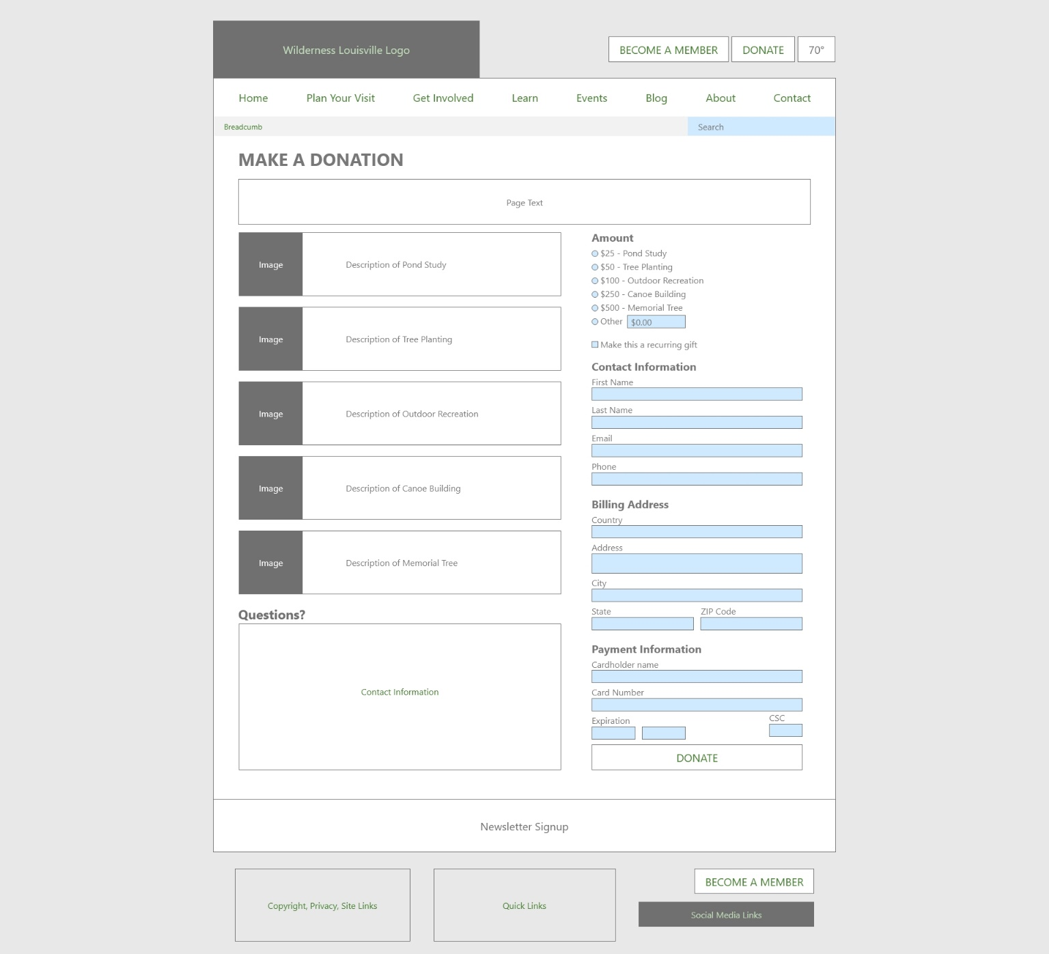Donation / Membership Pages

The design for our projected donation and membership pages. Wilderness Louisville’s donation and membership forms are very similar, containing different levels of donations and membership with information describing each level to the user. Unlike the current website, ours will bring both, the information page and the form for the donations/memberships together into one page. The user will be able to compare while filling out the form. The left column also includes a section containing contact information in case the user has any questions.

**Color Legend:** Green text means it contains a hyper-link. A green background means it could potentially contain hyper-links or other multi-media content. A dark gray background means it contains an image. A blue background means it is part of an input or text field for the user to input data.

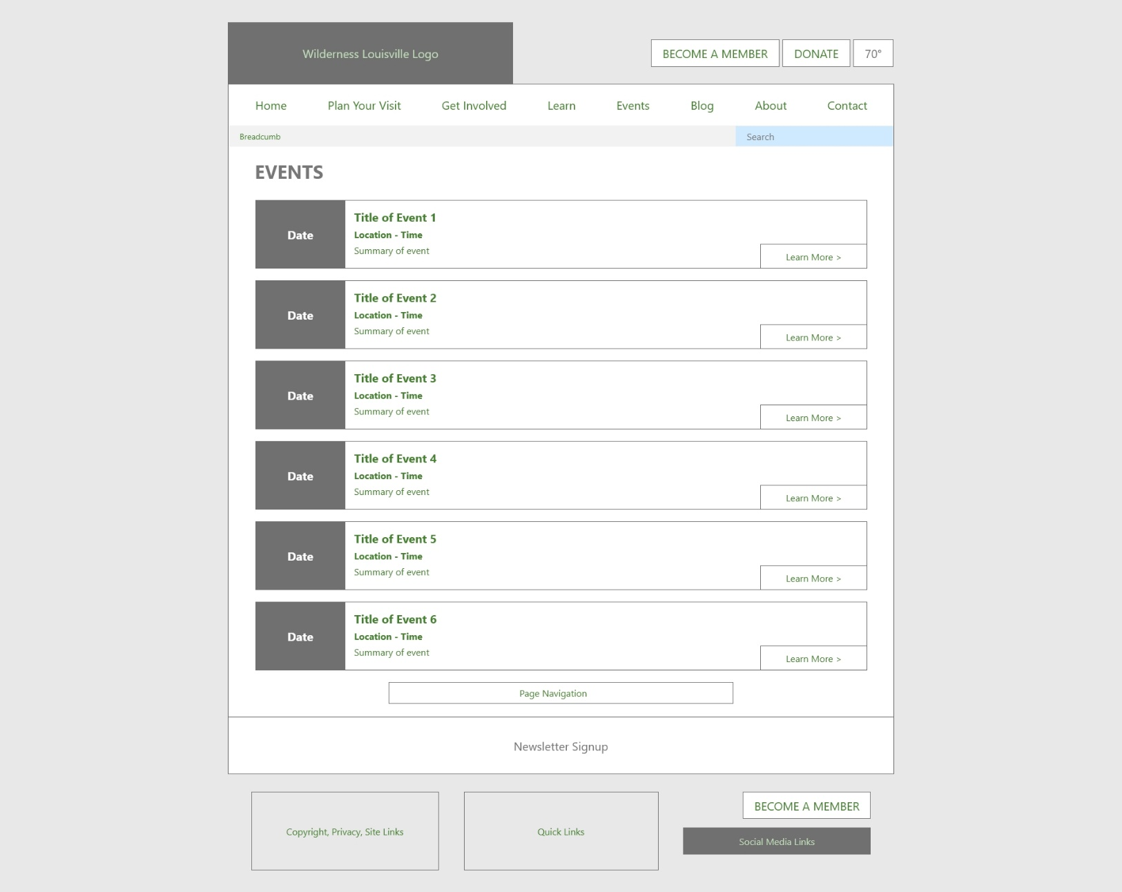

Events / Blog Listings Page

The design for our projected events and blog listing pages. This design utilizes the full page to show an overview of events or blog posts. Each listing will display a small thumbnail of the blog post or a space showing the date of the event, along with the title and a summary of the listing. Event listings will show the location and time of the event while blog listings will show the date the post was published. A navigation bar sits below the listings for the user to view more.

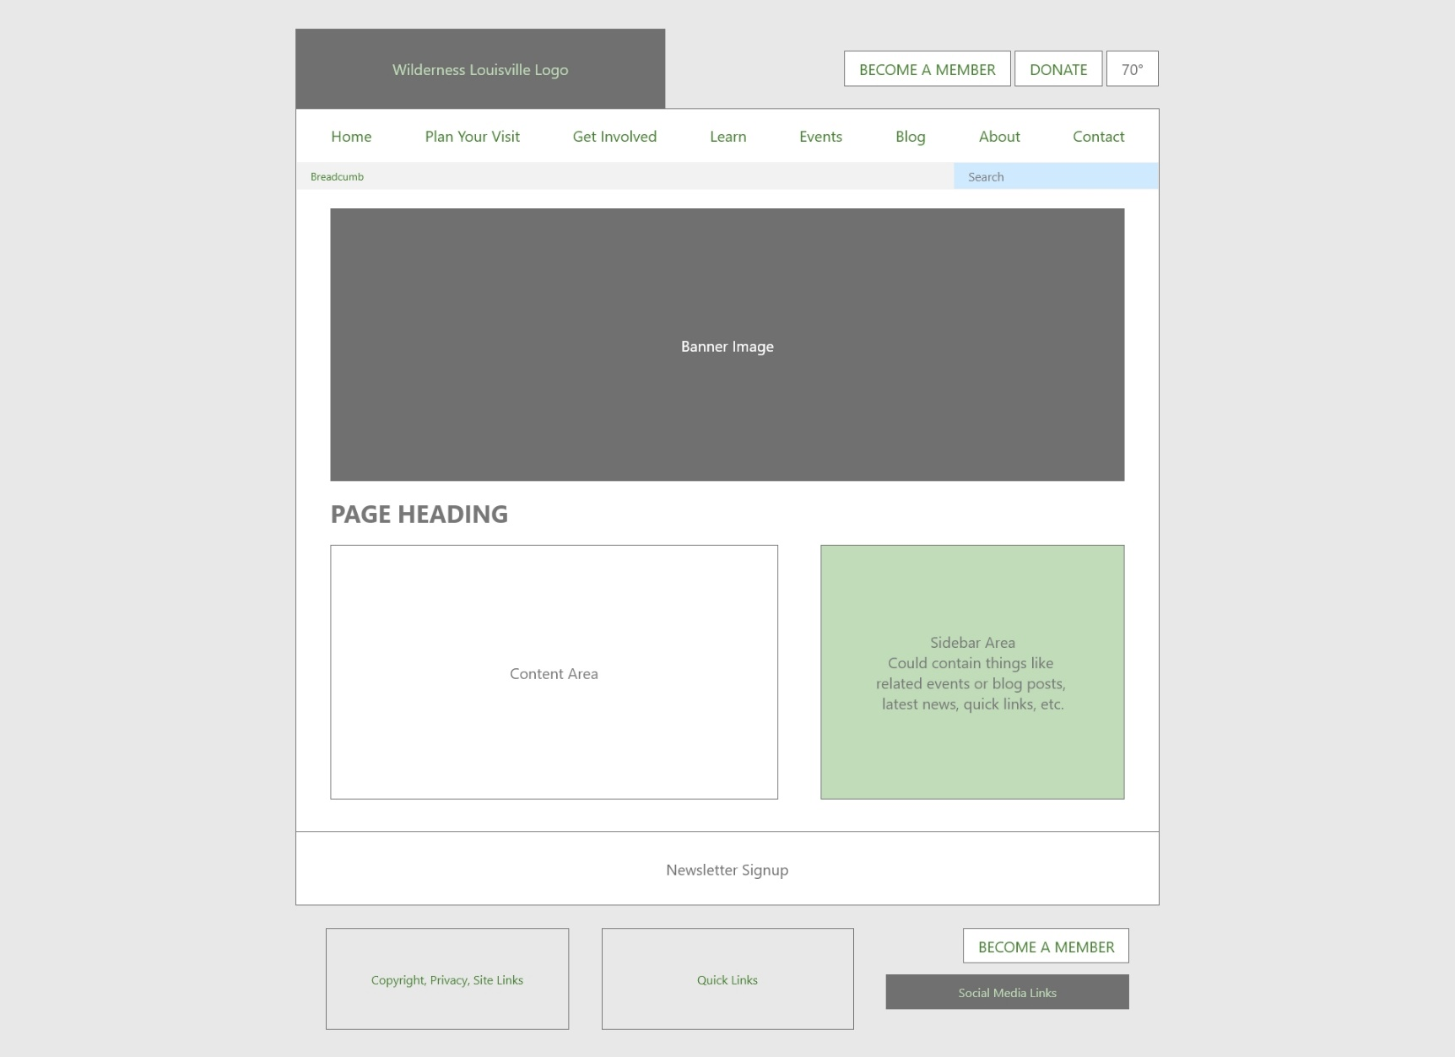

Information Page

This is a generic design for a page displaying information to the user. A banner image give the page a feel for what the information is about. A large column to the left is reserved all the information and content related to the topic at hand. The smaller right column is used to display material related to the topic or other content the user may want to see. We project this design will be used for pages about park information, learning, etc.

**Color Legend:** Green text means it contains a hyper-link. A green background means it could potentially contain hyper-links or other multi-media content. A dark gray background means it contains an image. A blue background means it is part of an input or text field for the user to input data.

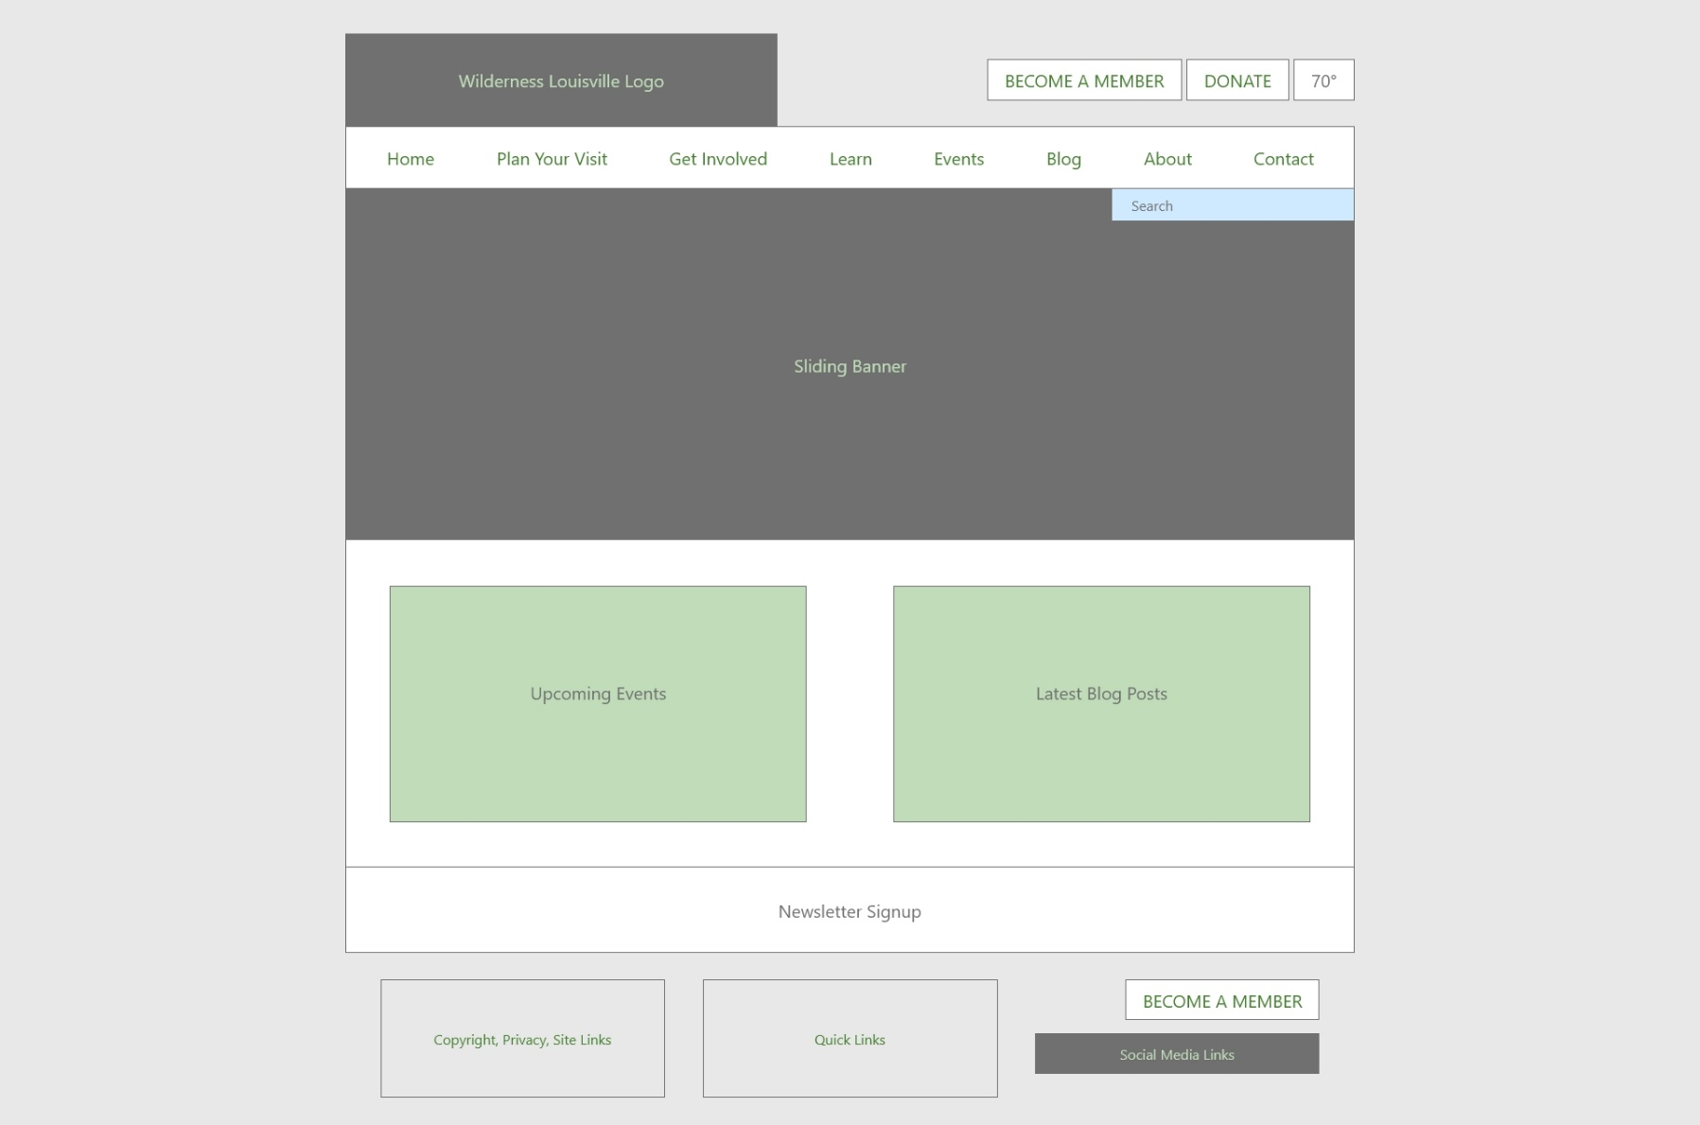

Landing Page

The design for our projected home page of the site. The header, navigation bar, and footer are designed to transfer to each page in same place to give each subsequent page the same look as the home page.

**Color Legend:** Green text means it contains a hyper-link. A green background means it could potentially contain hyper-links or other multi-media content. A dark gray background means it contains an image. A blue background means it is part of an input or text field for the user to input data.