Group member names: Aaron Henry, Max Phillips, Ulani Bouataveth, Dhara Patel, Ryan Bell, Michael Ly

**Exercise 3: Problem Solving** (5 points)

**Instructions:**

1. This is a group assignment. You only need to submit one solved exercise per group.
2. Provide your responses on this file, save it, and upload the file to the appropriate assignment response in blackboard.
3. You may upload as many attempts as you may like. Please note that only the most recent file uploaded file would be graded.
4. Do not handwrite any responses.
5. If you have any additional information you would like me to know about this assignment, you may provide that to me at the end of this document as a note.

**Identify each relationship type and write all of the business rules for the business shown below:**

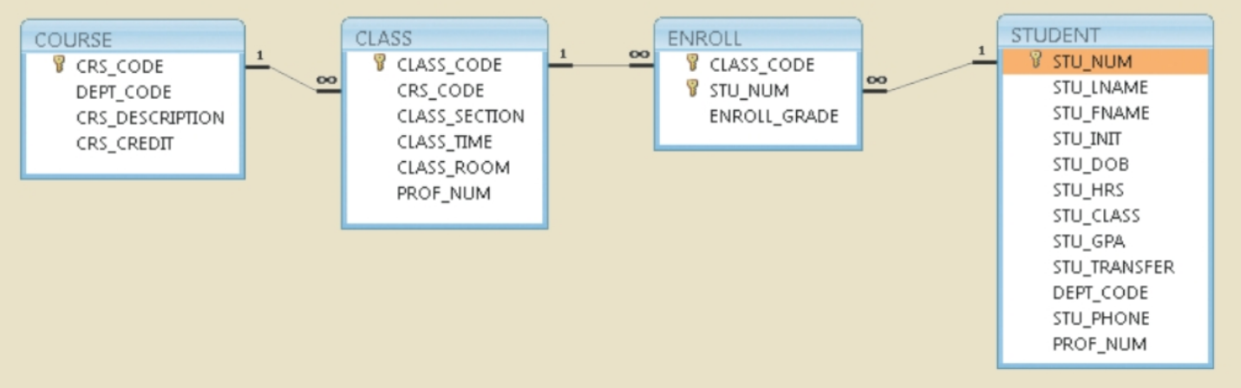

The relationship between COURSE and CLASS is a one-to-many. A single COURSE can reference many CLASSES. Within the CLASS entity there are multiple CLASSES that can reference a single COURSE. The relationship between CLASS and ENROLL is also a one-to-many. A single CLASS can have many ENROLLED students. Because ENROLL uses a composite key there can be only one ENROLLMENT per student for a given CLASS. The relationship between ENROLL and STUDENT is a many-to-one. There can be many unique ENROLLMENTS by a single STUDENT.